Insert your name, centre number and candidate number into the header above.
Save this evidence document as evidence_ followed by your centre number_ candidate number. For example: evidence_ zz999_9999
Screenshots or program listings must be copied into appropriate cells in the following tables.
Examiners must be able to read the contents including any screenshots without the use of a magnifying glass. Answers that are not readable or missing will not be awarded any marks.
Save this evidence document at regular intervals, for example, every 10 minutes.
Question 1
Part 1(a)
class Node:
def __init__(self, data: int, nextNode: int) -> None:
self.data = data
self.nextNode = nextNode

def __repr__(self):
return f"<Node data={self.data} nextNode={self.nextNode}>"

Part 1(b)
startPointer = 0
emptyList = 5
data = [[1, 1], [5, 4], [6, 7], [7, -1], [2, 2], [0, 6], [0, 8], [56, 3], [0, 9], [0, -1]]
linkedList = []
for item in data:
linkedList.append(Node(data=item[0], nextNode=item[1]))
# print(linkedList)

Part 1(c)(i)
def outputNodes(linkedList, pointer):
while True:
if (pointer == -1):
break
print(f"{linkedList[pointer].data}")
pointer = linkedList[pointer].nextNode

Part 1(c)(ii)
outputNodes(linkedList=linkedList, pointer=startPointer)

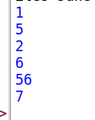

Part 1(d)(i)
def addNode(linkedList, currentPointer, emptyList) -> bool:

data = input("?) Input data: ")
try:
data = int(data)
except ValueError:
print("addNode() -> `data` should be of type int")
return False

if (emptyList < 0) or (emptyList > 9):
print("List is full")
return False

previous_pointer = 0
while (currentPointer != -1):
previous_pointer = currentPointer
currentPointer = linkedList[currentPointer].nextNode
linkedList[previous_pointer].nextNode = emptyList
emptyList = linkedList[emptyList].nextNode
return True

Part 1(d)(ii)
rval = addNode(linkedList=linkedList, currentPointer=startPointer, emptyList=emptyList)
if rval is True:
print("! Item added successfully")
else:
print("! Item not added")
outputNodes(linkedList=linkedList, pointer=startPointer)

Part 1(d)(iii)
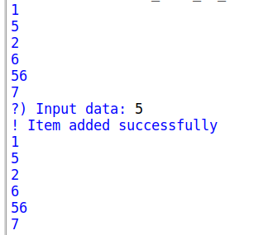

Question 2
Part 2(a)
arrayData = [10, 5, 6, 7, 1, 12, 13, 15, 21, 8]

Part 2(b)(i)
def linearSearch(searchFor: int):
global arrayData
for item in arrayData:
if item == searchFor:
return True
return False

Part 2(b)(ii)
while True:
inp = input("? Enter an integer: ").strip()
try:
if "." in inp: # float / decimal is entered
raise ValueError
inp = int(inp)
break
except ValueError:
print("Please enter a valid integer")
except Exception as e:
print(f"Another error occured: {e}")
isFound = linearSearch(searchFor=inp)
if isFound is True:
print(f"Found {inp} in `arrayData`")
else:
print(f"{inp} NOT found in `arrayData`")

Part 2(b)(iii)
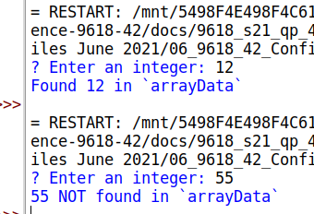

Part 2(c)
def bubbleSort(arr):
n = len(arr)
for i in range(n):
for j in range(0, n-i-1):
if arr[j] > arr[j+1]:
arr[j], arr[j+1] = arr[j+1], arr[j]
return arr

done= bubbleSort(arr=arrayData)
print(done)

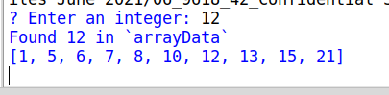

Question 3
Part 3(a)
class TreasureChest:
def __init__(self, question: str, answer: int, points: int) -> None:
self.__question = question
self.__answer = answer
self.__points = points

def __repr__(self):
return f"<TreasureChest question='{self.__question}' answer={self.__answer} points={self.__points}>"

Part 3(b)
arrTreasure = []
def readData():
try:
with open("TreasureChestData.txt", "r", encoding="utf-8") as file:
dataFetched = (file.readline()).strip()
while(dataFetched != "" ):
question = dataFetched
answer = int(file.readline().strip())
points = int(file.readline().strip())
arrTreasure.append(
TreasureChest(
question=question,
answer=answer,
points=points
)
)
dataFetched = file.readline().strip()
except (IOError, FileNotFoundError):
print("File not found")
except Exception as e:
print(f"Another error occured: {e}")

Part 3(c)(i)
def getQuestion(self) -> str:
return self.__question

Part 3(c)(ii)
def checkAnswer(self, answer: int) -> bool:
if answer == self.__answer:
return True
else:
return False

Part 3(c)(iii)
def getPoints(self, attempts) -> int:
if attempts == 1:
return int(self.__points)
elif attempts == 2:
return int(self.__points) // 2
elif attempts in [3, 4]:
return int(self.__points) // 4
else:
return 0

Part 3(c)(iv)
def inputInt(query: str) -> int:
return int(input(query))

readData()
qnum = inputInt(query="? Pick treasure to open [1-5]: ")
if (qnum > 0) and (qnum < 6):
result = False
attempts = 0
while (result == False):
answer = inputInt(query=f"? Solve: {arrTreasure[qnum-1].getQuestion()} = ")
result = arrTreasure[qnum-1].checkAnswer(answer=answer)
attempts += 1
print(f"! You have {arrTreasure[qnum-1].getPoints(attempts=attempts)} points.")

Part 3(c)(v)
